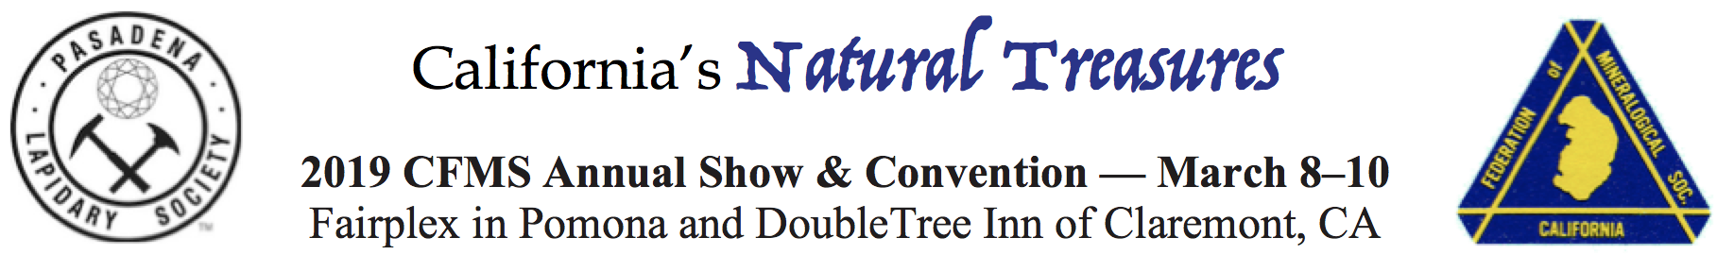

ADVANCE REGISTRATION AND TICKETS
Deadline: February 25, 2019

Registration will be recorded under this name – PLEASE PRINT CLEARLY

Name ____________________________________
Address __________________________________
City _____________________________________
State _____ ZIP ______________
Phone (_____)_____________________________
Email ____________________________________
Club Affiliation ____________________________
Exhibitor? ___Yes ___No

Additional Registrants – PLEASE PRINT CLEARLY
__________________________________________ Club _____________________________________
__________________________________________ Club _____________________________________
__________________________________________ Club _____________________________________

Show Admission Fees (pick up 3-day passes at the ticket window on Friday, March 8)
_____ Adult tickets @ $5 per day OR _____ 3-day pass for $12 Total $__________
_____ Senior (60+) tickets @ $4 per day OR _____ 3-day pass for $10 Total $__________
_____ Active Military @ $4 per day OR _____ 3-day pass for $10 Total $__________
_____ Juniors (12–17) @ $4 per day OR _____ 3-day pass for $10 Total $__________
Children 11 and under are free when accompanied by a paid adult.
Demonstrators and Exhibitors will receive complimentary admission for themselves and 1 guest.
Total admission cost for above registrants $__________

Banquet reservations (Double Tree Inn, 555 W Foothill Blvd, Claremont, CA)
• Editors Lunch: Saturday, March 9, at 1 p.m.
_____ Reservations @ $38.50 each $__________
• Banquet: Saturday, March 9. Happy Hour at 6 p.m., Dinner at 7 p.m. Awards to follow.
_____ Reservations @ $52.50 each $__________
How many: _____ Beef _____ Chicken _____ Vegetarian
Does not include alcoholic beverages. A no-host bar will be available.

Grand Total $__________

Questions? Email registration@pasadenalapidary.org.

Make check payable to Pasadena Lapidary Society 2019 CFMS Show. Mail to:
Sandie Fender
c/o Pasadena Lapidary Society 2019 CFMS Show
PO Box 5025
Pasadena, CA 91117-0025
In addition to mailing, please bring a copy of this form to the show.

